**Compiler Design**

**Assignment-1**

**SUBMITTED BY-**

Name – Ankit Goyal

Roll no - 17103011

Group - G-1

Branch - CSE

**SUBMITTED TO-**

Dr. Aruna Mailk

CSE Department

**Q1. What is Code optimisation? Explain machine dependent and independent code optimisation.**

Ans :

The code optimization in the synthesis phase is a program transformation technique, which tries to improve the intermediate code by making it consume fewer resources (i.e. CPU, Memory) so that faster-running machine code will result. Compiler optimizing process should meet the following objectives :

* The optimization must be correct, it must not, in any way, change the meaning of the program.
* Optimization should increase the speed and performance of the program.
* The compilation time must be kept reasonable.
* The optimization process should not delay the overall compiling process.

**Types of Code Optimization –**The optimization process can be broadly classified into two types :

* **Machine Independent Optimization –** This code optimization phase attempts to improve the **intermediate code** to get a better target code as the output. The part of the intermediate code which is transformed here does not involve any CPU registers or absolute memory locations.
* **Machine Dependent Optimization –** Machine-dependent optimization is done after the **target code** has been generated and when the code is transformed according to the target machine architecture. It involves CPU registers and may have absolute memory references rather than relative references. Machine-dependent optimizers put efforts to take maximum **advantage** of the memory hierarchy.

**Q2. Write a short note with example to optimise the code**

1. **Dead Code elimination**

Code that is unreachable or that does not affect the program (e.g. dead stores) can be eliminated.

int global;  
void f ()  
{  
 int i;  
 i = 1; /* dead store *  
 global = 1; /* dead store */  
 global = 2;  
 return;  
 global = 3; /* unreachable */  
}

This is the code after Dead code elimination

int global;

void f ()

{

global = 2;

return;

}

1. **Variable elimination**

Removing extra variables, which are not used in the code.

//Before Optimization

c = a * b

x = a

till

d = x * b + 4

//After Optimization

c = a * b

x = a

till

d = a * b + 4

1. **Code motion**

This reduces evaluation frequency of expression.

a = 200;

 while(a>0)

 {

     b = x + y;

     if (a % b == 0}

     printf(“%d”, a);

   }

//This code can be further optimized as

a = 200;

b = x + y;

while(a>0)

 {

     if (a % b == 0}

     printf(“%d”, a);

   }

1. **Reduction in strength**

Strength reduction means replacing the high strength operator by the low strength.

i=1;

while (i<10)

{

    y = i * 4;

}

//After Reduction

i = 1

t = 4

{

   while( t<40)

   y = t;

   t = t + 4;

}

**Q3. Explain how code motion and frequency reduction used for loop optimisation ?**

Ans:

**Frequency reduction** is a type in loop optimization process which is machine independent. In frequency reduction code inside a loop is optimized to improve the running time of program. Frequency reduction is used to decrease the amount of code in a loop. A statement or expression, which can be moved outside the loop body without affecting the semantics of the program, is moved outside the loop. Frequency Reduction is also called Code Motion.

**Objective of Frequency Reduction:**

* To reduce the evaluation frequency of expression.
* To bring loop invariant statements out of the loop.

**Q4. How to recognise various tokens of high level language program? Write the regular expressions and transitions diagram for each.**

Ans:

The lexical analyzer needs to scan and identify only a finite set of valid string/token/lexeme that belong to the language in hand. It searches for the pattern defined by the language rules.

Identifier :   
 Letter 🡪 a|b|c|…|z|A|B|…|Z  
 Digit 🡪 0|1|…|9  
 identifier 🡪 letter(letter|digit)*

Unsigned Number in C  
 digit 🡪 0|1|…|9  
 digits 🡪 digit+  
 fraction 🡪 ‘.’digits|€  
 exponent 🡪 (E(‘+’|’-’|€)digits)| €  
 number 🡪 digits fraction exponent

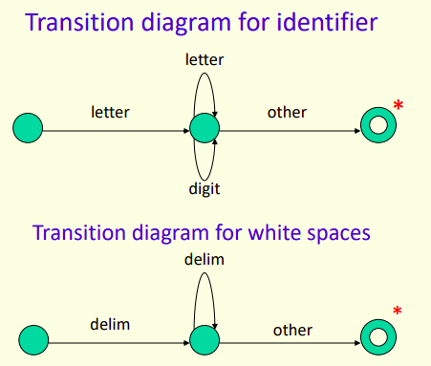

**Q5. Generate 3 address code for given pseudo code  
while(i<=100){  
A = A/B*20;  
++i;  
print(A value)  
}**

Ans:

i = 0

L: t1 = A/B  
 t2 = t1*20  
 A = t2  
 i = i+1  
 print(A)  
 if i<=100 goto L